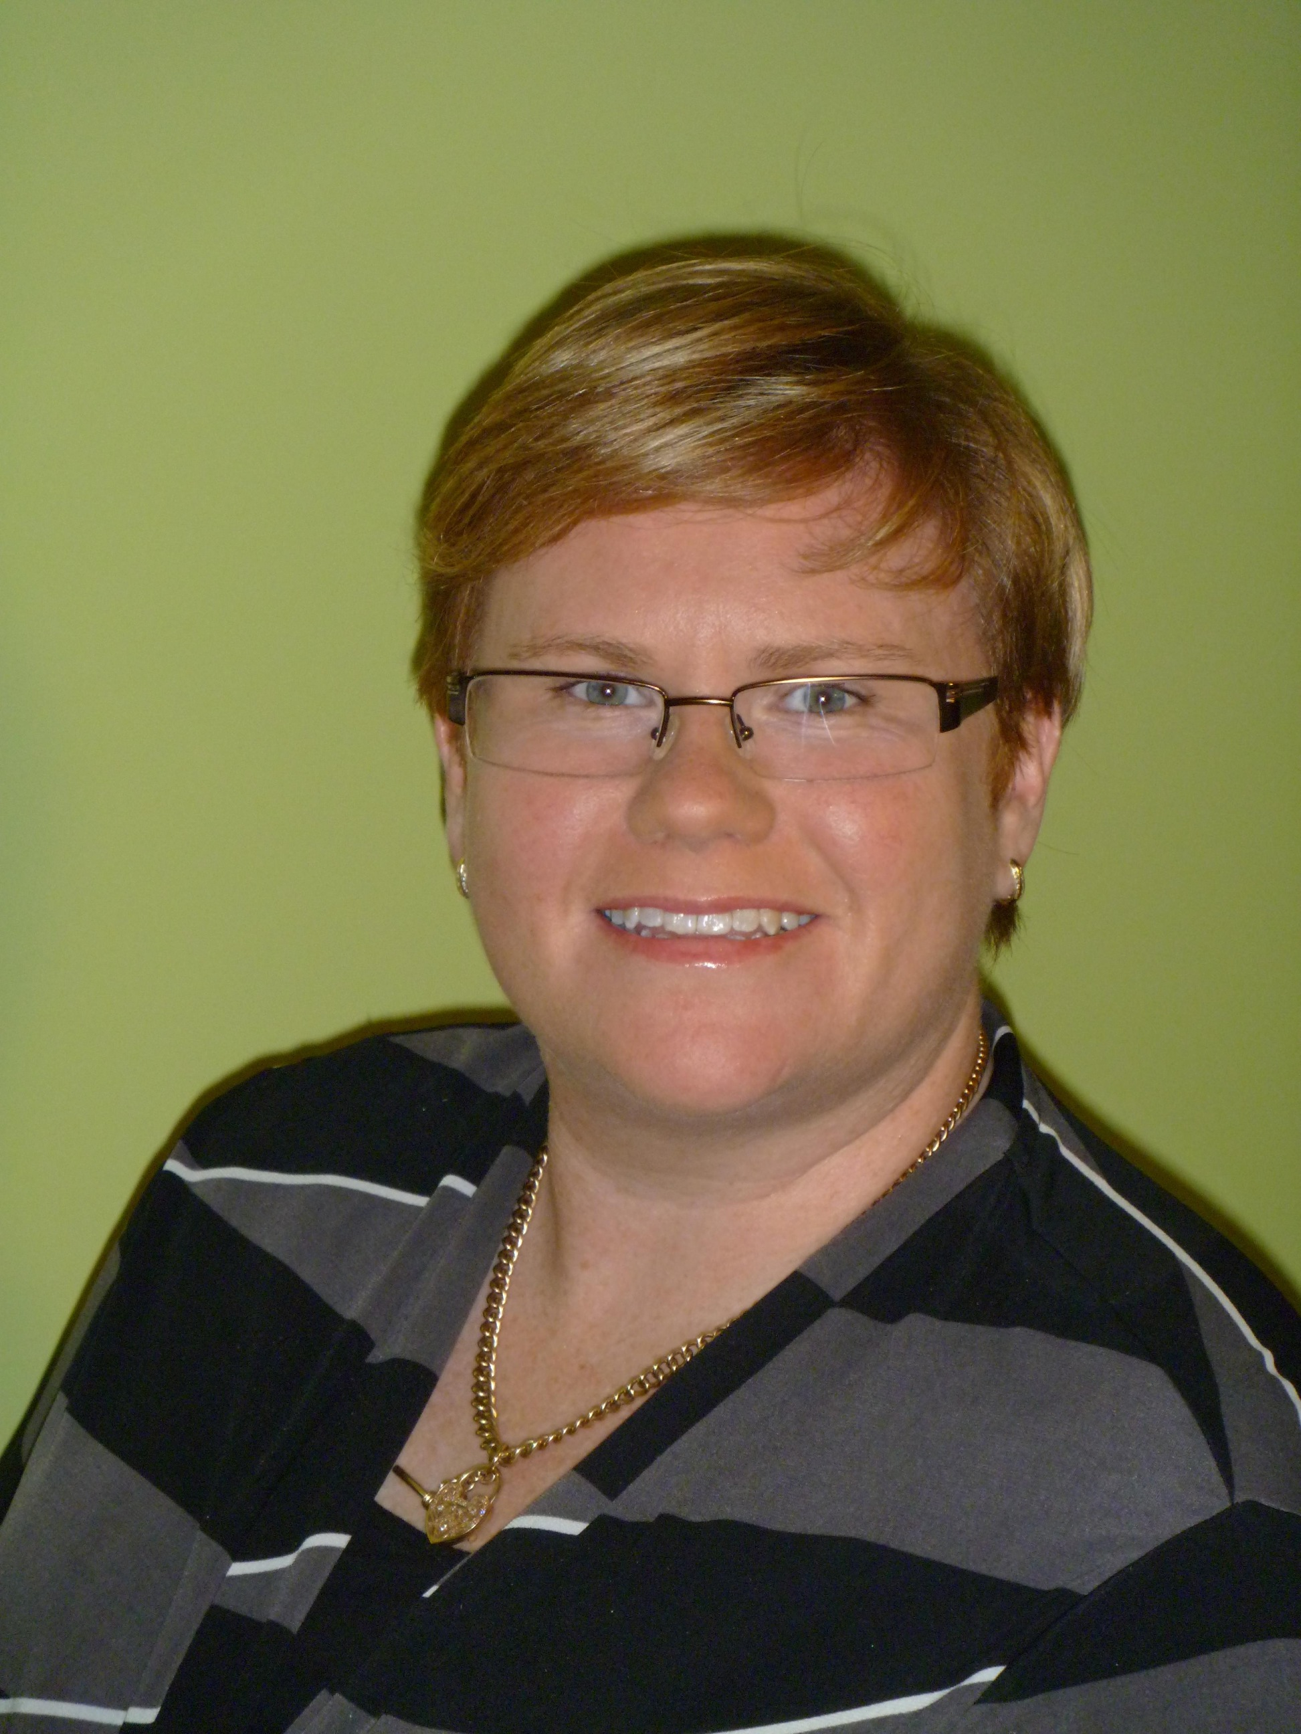

PMINZ National Conference 2012

The Faces and Facets of Project Management - Connect, Collaborate and Integrate.
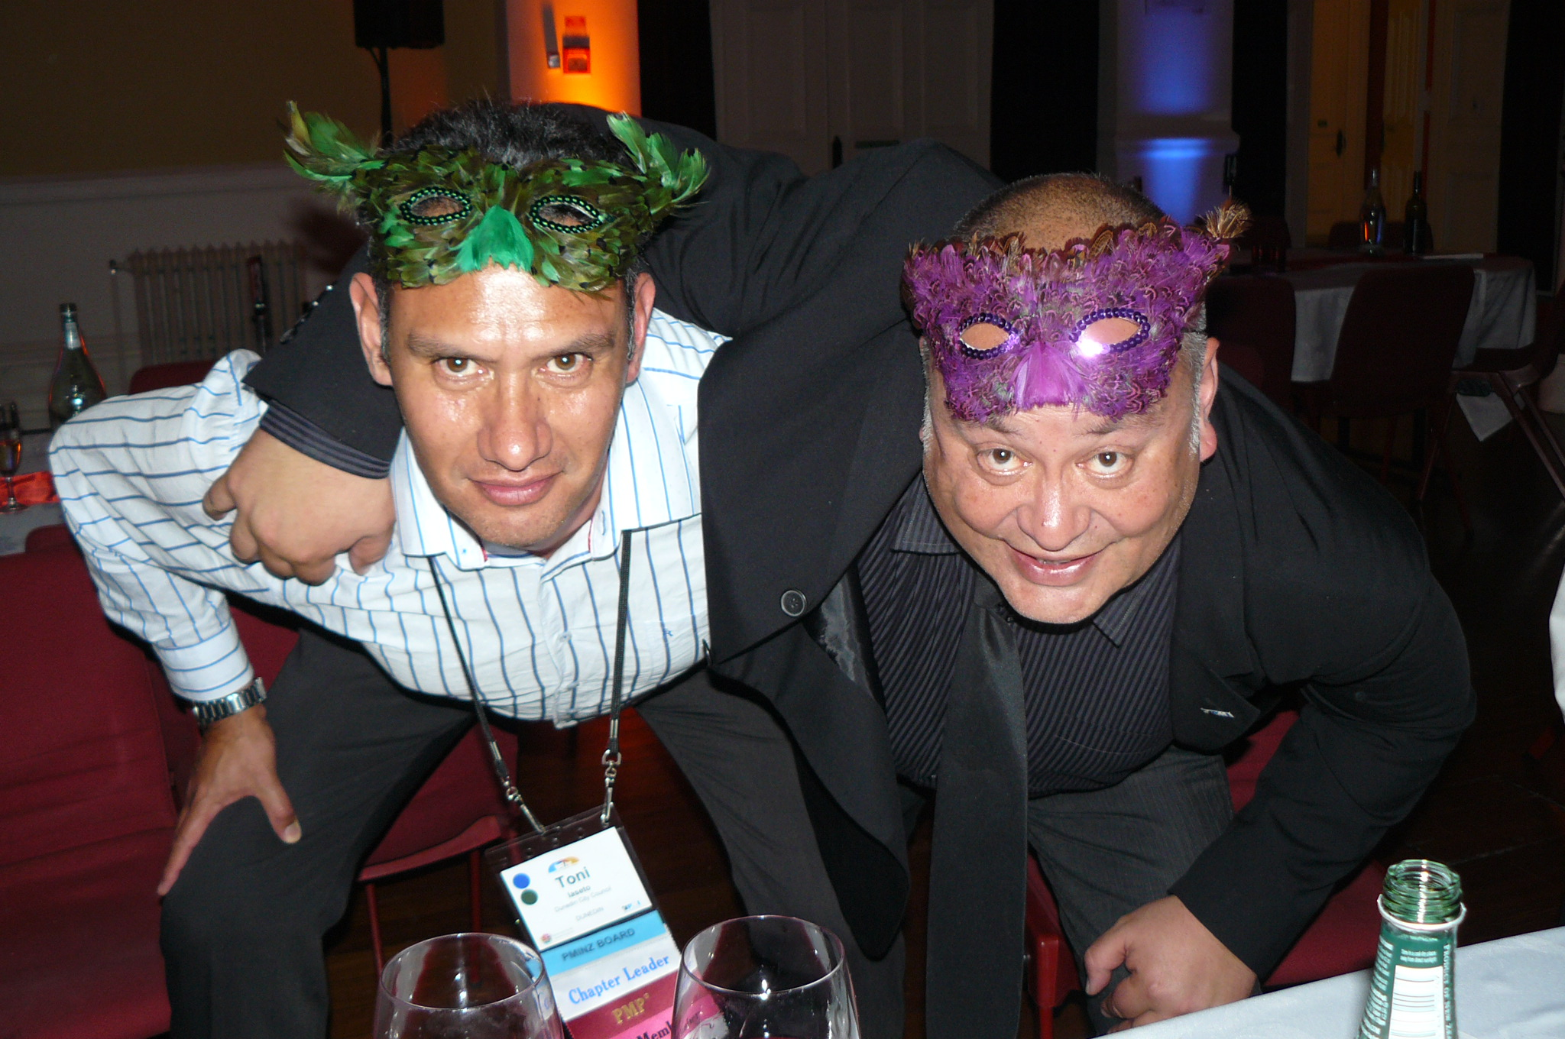
Wellington, New Zealand hosted a fantastic PMI National Conference 24 -26 September which I was proud to attend on behalf of the Sydney Chapter Board and its members. With my partners in crime from the PMIAUS 2013 Conference team Adrian Pearce (technology lead) and Frank Papa (Change Management lead) we set out to experience how the Kiwi's do it and get inspiration for what we can add to our ideas.
The conference was opened with a traditional Powhiri ceremony which Adrian and I were honoured to take part in. The opening keynote speaker Lynne Schinella covered the topic: The Whole Brained Organisation - How Diversity Creates Profit. Lynne talked about the left brain traits (Maths, language, logic and analysis) and right brain traits (connections, imagination, communication) using an analogy of fruit. The aim for a company would be to have a "fruit salad" team complimenting each other with their different styles. By embracing the diversity of the team, we can respect and use the differences rather than fighting them.
News from the Events Director
I was lucky enough to listen to the stories of the Emerging Project Manager for 2011 Alice Greer and Project Manager of the year for 2010 Byron Roff. They shared inspiring stories of why they won their award and how it had changed their career. A definite reason for you to put in your application for the Australian National Awards that will be held at the gala dinner with our PMIAUS Conference (1-3 May 2013).
Keynote 2 was delivered by Dr Diane Parente whose topic was: The Importance of Project Strategy and Implementation of Strategy through Projects- Understanding the Difference. She started with a saying "if you don't know where you are going, any road will take you there". Covering the main items of creating a strategy, Dr Parente challenged us to look at SWOT analysis in the following ways;
- SO - how can I use my strengths to capitalise on the opportunities?
- WO - what opportunity to I have to overcome my weakness?
- ST - what strength can I use over overcome my threat?
- WT - what can I develop to overcome my weakness and remove the threat?

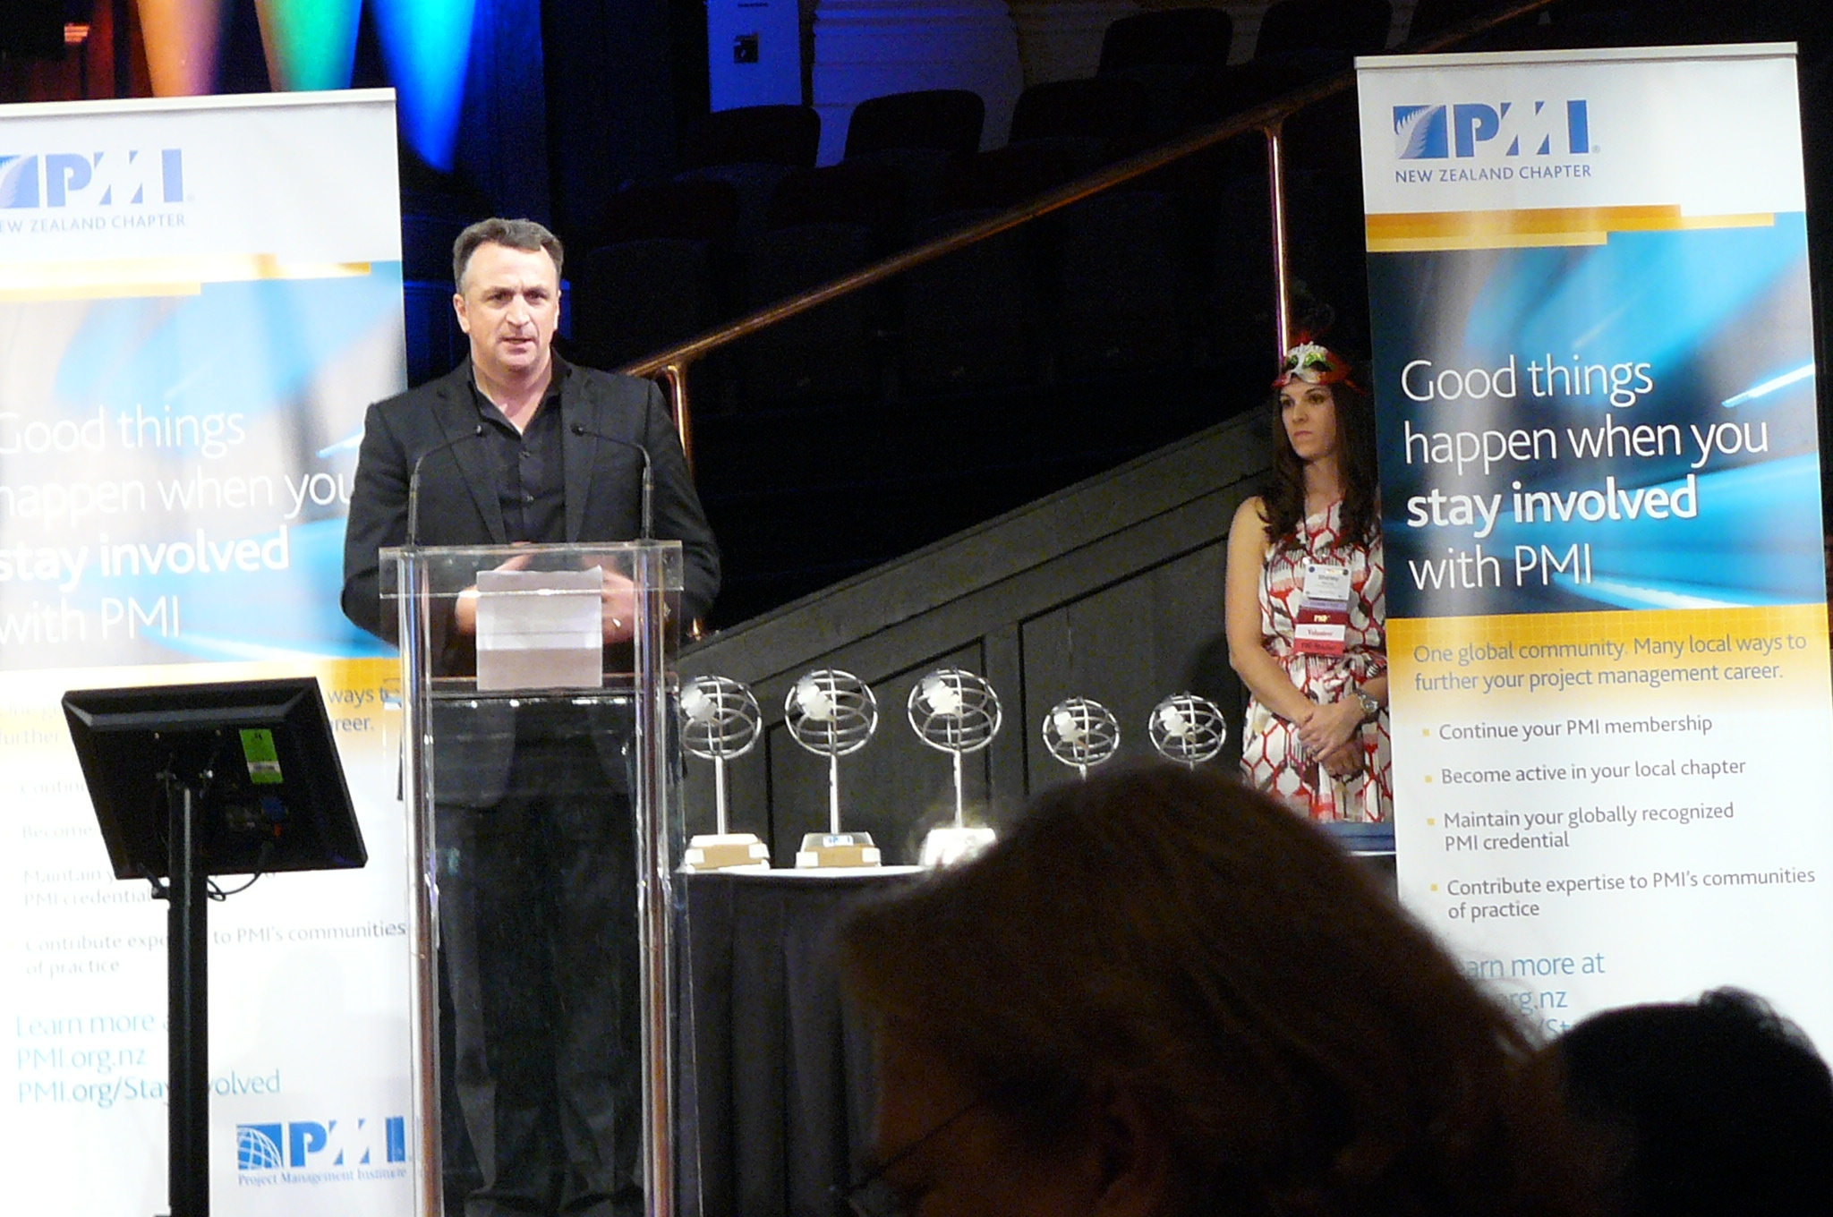
The awards dinner was a great night for all the delegates to enjoy and celebrate the 'best of the best' in our field. It was great to see so many fantastic and well deserved people and projects being recognised and rewarded.
Day two of the conference and it started off with a keynote from Beth Partleton (Immediate Past Chair 2012 Board of Directors) on the Value of Project Management for Society, Organisations and the Practitioner. Looking at the global economy we are seeing a changing of the guard, as GDP for America, Canada and parts of Europe slow down, India and China’s GDP grows. We also see that the industries that boomed for skilled workers in the 70's are bracing for a large percentage of their workers retiring in the next 10 years. What this tells us is that there is a significant opportunity we can all be part of as project management professionals in the years to come. Exciting times ahead!
So what was the best part of the conference? Well there are too many things to add in this article, so be sure to come and see me at an upcoming event.

